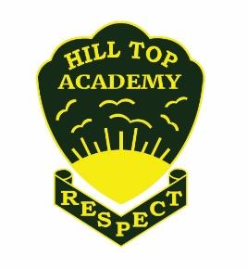

HILL TOP ACADEMY

PE Curriculum Intent
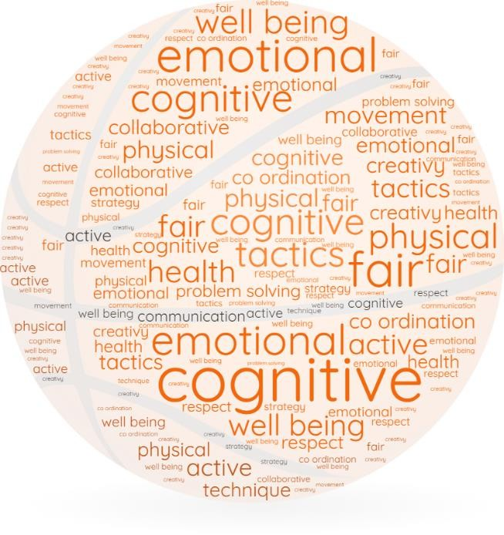
SEPTEMBER 1, 2025
PE SUBJECT LEAD

L Pawlett

Contents
Introduction 2
Whole school overview 7
Example of sequenced knowledge components

Introduction

Introduction
This document outlines the knowledge, language and concepts that should be taught in Physical Education. It includes:
- A summary of the knowledge and principles that underpin our approach to physical education
- Long Term Sequence (curriculum map) for PE
- Progression of knowledge and skills in PE including alignment with the National Curriculum. This is based on following the ‘YourPE’ scheme of work.

Intent

At Hill Top Academy, we recognise the importance of being active and the effect it has on a child’s health and wellbeing, their ability to learn effectively and achieve in school. As a school, we want to promote participation in sport and physical activity and believe we have an important role in partnership with the family and wider community in promoting physical activity and a healthy lifestyle.
Hill Top Academy is committed to promoting the health and well-being of its pupils and staff through physical activity. This policy outlines the organisation, teaching and management of physical activity at Hill Top Academy.
In align with the ‘YourPE’ scheme, we ensure development of the whole child by using four main concepts:
  - Physical
  - Social
  - Emotional
  - Cognitive

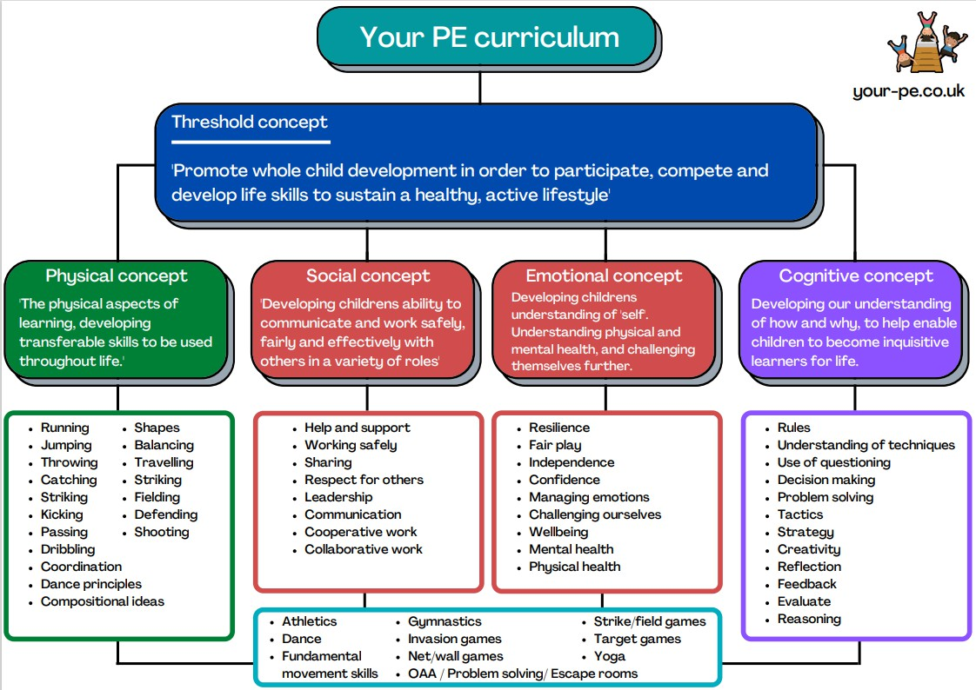

Implementation
We implement our intent utilising the ‘YourPE’ scheme consistently throughout school. Pupils in EYFS explore physical education through development of basic fundamentals of movement and the ability to share and work collaboratively with others. This progresses through to Key Stage one where children will develop more independent working. Pupils will build on the fundamental movement skills and progress to using these more specifically and begin to add an element of competition to learning. Pupils in Key Stage two will then progress to applying these skills to a range of more sports specific contexts, whilst still the main focus being on the four main concepts to develop the whole child. This ensures that we develop the pupils as individuals with high quality life skills.

Implementing Physical Literacy
The International Physical Literacy Association describes physical literacy as “the motivation, confidence, physical competence, knowledge and understanding to value and take responsibility for engagement in physical activities for life.” (IPLA, 2017)
The support systems around the child including parents, teachers & peers – Positive influences; role models, people encouraging and aiding physical activity. Positive experiences that the child encounters within and around physical activity. The physical environment around the child to offer a wide variety of opportunities and experiences. Age and ability appropriate activities and challenges for the child to achieve success and develop a feeling of worth. Physical literacy in itself is not something that can be taught directly as such, rather it is the by-product of exposure to physical opportunities and challenges through high quality PE and School Sport opportunities. By combining different areas, such as the physical competence of a skill set, confidence, motivation and resilience, knowledge of techniques and activities, rules, tactics, how to be healthy, etc., and the understanding of when and how to use it, we begin to develop a value and a love for being physically active throughout our lives. This is shown throughout our curriculum through our head, hand and heart concepts, ensuring that the whole child is developed throughout their journey from EYFS - Y6.
Although it starts from birth, primary school is a key period for allowing children to develop their physically literacy:
It is dependent on several factors:
With the right support and opportunities, this will lead the child, teenager, and then adult, to making and wanting to make good decisions about their health and own physical wellbeing. It will lead to an active life and choosing to be active for internal reasons.

Learning sequences
We organise intended learning into units. These group the knowledge, skills and understanding that we want children to remember, do and use. Each unit aims to activate and build upon prior learning, including from the early years, to ensure better cognition and retention. The skills required for working in a particular subject are outlined. Close attention is paid to specific vocabulary to be taught to allow pupils to engage in the required vocabulary. They are deliberately spaced within and across years to introduce and revisit key concepts. This enables staff to deepen pupil understanding and embed learning. Each module is carefully sequenced to enable pupils to purposefully layer learning from previous sessions to facilitate the acquisition and retention of key knowledge.

Lesson structure
We believe PE lessons should follow a similar structure to other curriculum lessons, therefore lessons typically are split into six phases:
- CONNECT This provides an opportunity to connect the lesson to prior learning from a previous module or lesson. Teachers return children’s attention to the previous lesson’s knowledge and skills including key vocabulary. A warm up might then include time to practise and re-visit a skill/movement from a previous lesson. Retrieval practice allows all pupils to take time to remember things and activate their memories. Quizzing allows questions to be asked and allows pupils to carry out retrieval practice. Cumulative quizzing, allows for a few questions to be asked each lesson, which are built upon the previous lesson.
- EXPLAIN This is the explicit teaching that needs to take place. Teachers should ensure they are clear what they want children to know and remember. They plan for and explicitly address common misconceptions so they can address these in lessons as they arise. They should be clear about the substantive knowledge and the vocabulary that they want children to understand in the session.
- EXAMPLE Providing pupils with high-quality examples is essential for learning. Teachers use a variety of methods of demonstration including self-demonstration, pupil demonstration, photos and high quality videos.
- ATTEMPT Children are given time to practise the skill/movement. This is sometimes individual practice or paired/group practice. This time should allow for high success rate. Teachers should be constantly assessing throughout and giving challenges to pupils who are achieving the higher attaining pupils.
- APPLY This is where pupils will typically apply the movement/skill taught to a variety of different situations depending on the key stage and the sport. Skills/movements are transferrable and the thread of developing the whole child though the four concepts outlined.
- REVIEW The learning outcome will be revisited along with key vocabulary and high quality questioning.

Impact

In order to identify the impact our curriculum is having on our pupils, we check the extent to which learning has become permanently embedded in children’s long-term memory in addition to looking for excellence in their outcomes. We use four main tools to quality assure the implementation and impact of our curriculum:
  - Learning observations help to evaluate subject knowledge, explanations, expectations, opportunities to learn, pupil responses, participation and relationships.
  - CPD staff are given the opportunity to regularly team teach alongside qualified sports coaches in order to develop their confidence teaching physical education.
.•Assessment and achievement can children articulate and display key skills and knowledge from specific units of learning.
  - Pupil voice helps to evaluate curriculum structures, teaching methods, pupil participation and response through a dialogic model.

When undertaking these we ask the following key questions
- How well do pupils remember the content that they have been taught?
- Do lesson observations and pupil discussions radiate excellence?
•Does learning ‘travel’ with pupils and can they deliberately reuse it in contexts that are more sophisticated?

Teachers employ a range of strategies both at and after the point of teaching to check the impact of their teaching on the permanence of pupils’ learning.
These include: retrieval practice, vocabulary use and application, deliberate practice and rephrasing of taught content, cumulative quizzing within the learning sequence, summarising and explaining the learning question from the sequence, tests and quizzes. Teachers use information from observing pupils from lesson to lesson, discussions before during and after lessons and other monitoring to support learning by responding to the gap between where pupils are and where they need to be. In lessons, they adapt explanations and examples to address misconceptions and provide additional practice or challenge where required. Teachers then adjust subsequent planned teaching in response.

We use formative assessment to generate a summative assessment overview. The use of formative assessment allows teachers to implement assessment for learning in order to effectively plan and deliver subsequent lessons to meet the needs of all children.

Pupil voice is used as a method to quality assure our curriculum by talking to the children. We do this after content has been taught to see the extent to which pupils are knowing more, remembering more and able to do more. In preparation, we review the planned content, knowledge and vocabulary, so that conversations with pupils are meaningful and focused on what has been taught. We also consider pupils’ participation and consider the explanations and models used, the tasks the pupils are asked to do and the ability to answer carefully selected questions. We ask careful questions that probe their knowledge, understanding and skills.

The Subject Leader undertakes a range of activities to understand what the curriculum looks like across the school and how well pupils know more, remember more and can do more as a result. In addition to the above tools, they use learning walks, lesson observations and pupil voice. They use their findings to support teachers to improve how they implement subjects and to make recommendations about the suitability of the intent for their subject. The Subject Leader formally reports on impact of the curriculum termly to the Curriculum Leader, Principal and Governors.

Whole School PE Overview

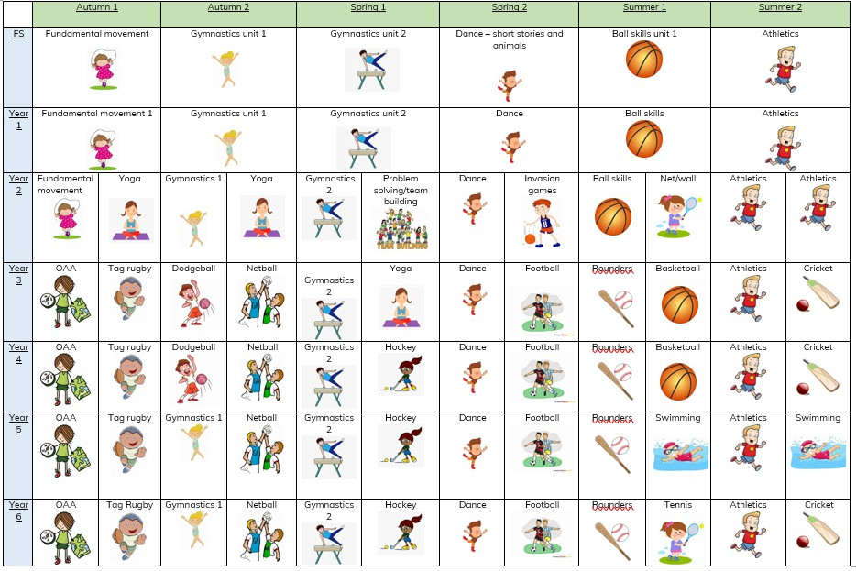

Link to Example of progression of skills

