HILL TOP ACADEMY
History Curriculum Intent
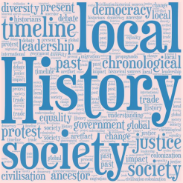
SEPTEMBER 1, 2025
CURRICULUM LEAD AND HISTORY SUBJECT LEAD
Antonia James and Katie Vardy
Contents
Introduction ……………………………………………………………………………………………………………………………………………………………………………………………………………………………………… 2 Whole school overview ……………………………………………………………………………………………………………………………………………………………………………………………………………………… 6 Whole school lens progression …………………………………………………………………………………………………………………………………………………………………………………………………………… 7 Example knowledge components
1
Introduction
Introduction
This document outlines the knowledge, language and concepts that should be taught in History.
It includes:
• A summary of the History knowledge and principles that underpin our approach
• Long Term Sequence (curriculum map) for History
• Progression of History including alignment with the National Curriculum, substantive concepts, lines of enquiry and key vocabulary.
Intent
Our History curriculum draws upon several powerful sources of History:
∙ Key Concepts – these are the key concepts that build and progress through our humanities curriculum. Mapped out in detail within the appendices of this document. The key concepts have been selected and cultivated in order to best meet the needs of the pupils within out academy and the context of the community in which they live.
Trade, food and farming Transport Community and culture Conflict and Economic conflict Power and hierarchy Exploration and invention
∙ Substantive knowledge-this is the subject knowledge and explicit vocabulary used about the past. Misconceptions are challenged carefully and in the context of the substantive and disciplinary knowledge. We do not introduce misconceptions too early, as pupils need to construct a mental model in which to position new knowledge.
∙ Disciplinary knowledge–this is the use of that knowledge and how children construct understanding through historical claims, arguments and accounts. We call it ‘Working Historically.’ The features of thinking historically in our History Curriculum are:
Cause and consequence Change and continuity Similarity and difference Historical significance Sources and evidence Historical Interpretations
Historical analysis is developed through selecting, organising and integrating knowledge through reasoning and inference making in response to our structured questions and challenges. We call this ‘Thinking historically’
History is planned so that the retention of knowledge is much more than just ‘in the moment knowledge’. The cumulative nature of the curriculum is made memorable by the implementation enquiry-led learning, including retrieval and spaced retrieval practice, word building and deliberate practice tasks. This powerful interrelationship between structure and research-led practice is designed to increase substantive knowledge and accelerate learning within and between units of learning. That means the foundational knowledge of the curriculum is positioned to ease the load on the working memory: new
2
content is connected to prior learning. The effect of this cumulative model supports opportunities for children to associate and connect significant scientific concepts, over time, and with increasing expertise and knowledge. History curriculum strategically incorporates a range of units that revisit, elaborate and sophisticate key concepts, events, people and places.
Implementation
We implement our intent using sequenced knowledge components and appendices to guide cognitive thinking. A guiding principle through the academy is that pupils become ‘more expert’ with each study and grow an ever broadening and coherent mental timeline. This guards against superficial, disconnected and fragmented understanding of the past. Specific and associated historical vocabulary is planned sequentially and cumulatively from Y1 to Y6. High frequency, multiple meaning words (Tier 2) are taught alongside and help make sense of subject specific words (Tier 3).
Learning sequences
We organise intended learning into units. These group the knowledge, skills and understanding that we want children to remember, do and use. Each unit aims to activate and build upon prior learning, including from the early years, to ensure better cognition and retention. Concepts and themes are deliberately spaced within and across years to introduce and revisit key learning. This enables staff to deepen pupil understanding and embed learning. Each unit is led by an overarching enquiry question and knowledge is carefully sequenced to enable pupils to purposefully layer learning from previous sessions to facilitate the acquisition and retention of key knowledge. To finalise learning sequences pupils are given opportunities to apply their learning in a final outcome.
Lesson structure
Lessons typically are split into six phases:
RETRIEVE This provides an opportunity to connect the lesson to prior learning from a previous unit or lesson. Teachers return children’s attention to the previous lesson’s learning enquiry or the overall learning enquiry for the learning unit, including key vocabulary and a cumulative whole school history timeline. Examples of thinking harder routines include Flash back 5, Recap questions and Quizzing. Retrieval practice allows all pupils to take time to remember things and activate their memories. Quizzing allows questions to be asked and allows pupils to carry out retrieval practice. Cumulative quizzing, allows for a few questions to be asked each lesson, which are built upon the previous lesson.
LINE OF ENQUIRY Pupils are introduced to new concepts through a shared learning enquiry. At this stage teachers think aloud to create links with prior learning and explicitly teach new vocabulary.
EXPLAIN/ MODEL This is the explicit teaching that needs to take place. Teachers should ensure they are clear what they want children to know and remember. They plan for and explicitly address common misconceptions so they can address these in lessons as they arise. They should be clear about the substantive knowledge and the vocabulary that they want children to understand in the session. This can be developed using key information, facts, and images so that explanations are precise. Providing pupils with high-quality examples is essential for learning. Pupils need to see worked examples. My turn, our turn, your turn is a technique that can be used to explicitly teach vocabulary and new concepts. Prepared examples should be carefully planned and need to be evident in teaching. Guiding pupil practice allows pupils to rehearse, rephrase and elaborate their learning. Children need the chance to attempt and verbalise their understanding. Children’s own attempts are what help them to secure their understanding. Children need to have time to struggle and understand for themselves. This is not necessarily something that is recorded in books. This phase provides opportunities for teachers to check in with pupils to see who may need more challenge/support/scaffolds and if any misconceptions have arisen that need to be addressed.
APPLICATION This is where pupils would typically begin to record in books. The number of scaffolds may vary. Pupils could work collaboratively, with support or independent to apply their knowledge.
CHALLENGE Where appropriate, teachers will include a challenge question. This may be discussion based or included within their application. This should aim to challenge pupils thinking or offer an alternate point of view.
3
REVIEW Teachers get the children to interrogate their learning -summarise, explain, compare and contrast. Tools are built into routines to reduce overload and allow for hard thinking. These can be adapted for children based on their individual needs.
Impact
In order to identify the impact our curriculum is having on our pupils, we check the extent to which learning has become permanently embedded in children’s long-term memory in addition to looking for excellence in their outcomes. We use tools to quality assure the implementation and impact of our curriculum:
•Learning observations help to evaluate subject knowledge, explanations, expectations, opportunities to learn, pupil responses, participation and relationships. •Assessment and achievement articulate the outcomes from tasks, how well the content is understood and what the strengths and limitations are; it informs what to do next. •Pupil Book Studies help to evaluate curriculum structures, teaching methods, pupil participation and response through a dialogic model.
When undertaking these we ask the following key questions
• How well do pupils remember the content that they have been taught?
• Do books and pupil discussions radiate excellence?
• Does learning ‘travel’ with pupils and can they deliberately reuse it in differing contexts?
Teachers employ a range of strategies both at and after the point of teaching to check the impact of their teaching on the permanence of pupils’ learning. These include: retrieval practice, vocabulary use and application, deliberate practice and rephrasing of taught content, cumulative quizzing within the learning sequence, summarising and explaining the learning question from the sequence. Teachers use information from tasks, pupil book studies and other monitoring to support learning by responding to the gap between where pupils are and where they
need to be. In lessons, they adapt explanations and examples to address misconceptions and provide additional practice or challenge where required. After lessons, they analyse pupils’ responses to identify shared and individual gaps in learning and misconceptions. Teachers then adjust subsequent planned teaching in response.
We use summative assessment is ‘to provide an accurate shared meaning without becoming the model for every classroom activity’ (Christodolou, 2017). If our curriculum is effective, it will lead to improvements in summative assessments over time. Teacher assessment judgements are against an agreed assessment model (the curriculum). We make summative judgements termly. Teachers record summative judgements on OTrack.
Pupil book study is used as a method to quality assure our curriculum by talking to the children and looking in pupils’ books. We do this after content has been taught to see the extent to which pupils are knowing more, remembering more and able to do more. In preparation, we review the planned content, knowledge and vocabulary, so that conversations with pupils are meaningful and focused on what has been taught. When looking at books, we look at the content and knowledge, teaching sequence and vocabulary. We also consider pupils’ participation and consider the explanations and models used, the tasks the pupils are asked to do, the ability to answer carefully selected questions and retrieve information and the impact of written feedback. We ask careful questions that probe their knowledge, understanding and skills.
The Subject Leader undertakes a range of activities to understand what the curriculum looks like across the school and how well pupils know more, remember more and can do more as a result. In addition to the above tools, they use learning walks, planning reviews and book looks. They use their findings to support teachers to improve how they implement subjects and to make recommendations about the suitability of the intent for their subject. The Subject Leader formally reports on impact of the curriculum termly to the Curriculum Leader, Principal and Governors via action planning and analysis.
4
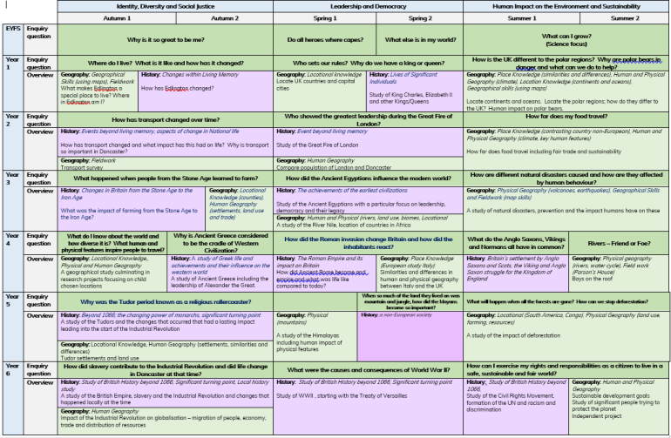5

6

Key Knowledge Components for History Example
7
8

