

Calculation Policy - Primary

Status | Non-Statutory
Responsible Directors’ Committee | Board of Directors
LGB Committee | Local Governing Board
Responsible Persons | Sarah Cope in conjunction with members of Maths Network
Date Policy Agreed | Spring 2022
Last Review Date | -
Next Review Date | Spring 2026

Table of Contents
Introduction 3
Addition Year 1 5
Addition Year 2 7
Addition Year 3-6 13
Subtraction Year 1 17
Subtraction Year 2 20
Subtraction Year 3-6 22
Multiplication Year 1 25
Multiplication Year 2 27
Multiplication Year 3 30
Multiplication Year 4 31
Multiplication Year 5-6 33
Multiplication Year 6 36
Division Year 1 37
Division Year 2 39
Division Year 3 40
Division Year 4 - 6 43
Division Year 6 46
Version Control
Version | Revision Date | Revised by | Section Revised



Introduction

This policy has been largely adapted from the White Rose Maths Hub Calculation Policy with further material added. It is a working document and will be revised and amended as necessary. This is a product of collaboration between all Exceed Maths Leaders and supports, unifies enhances the approaches already in place.

The purpose of a shared approach is to support teacher understanding and pedagogy; ensure there is consistency to support moderation and year group networks and to support more collaborative training/coaching opportunities within Mathematics.

Documents to further support the Teaching and Learning of Maths created/distributed by colleagues within the Maths Network are:
- Diagnostic Assessment Document
- Mental Maths & Arithmetic Progression Document
- Teacher Prompt Document
- Sentence Stems
- Knowledge Organisers

Manipulatives
Throughout the policy examples of concrete and pictorial examples are shared. These are not an exhaustive list. Through using the accompanying Teacher Prompt Document individual teachers will be able to consider precisely which manipulatives and models need to be used with each particular group of pupils. Manipulatives and pictorial models should be used in every year group for all abilities when introducing a new concept to ensure children can underpin their knowledge securely.

Everyday objects are also invaluable to support children’s learning to keep interest and help them understand that Maths is everywhere for example:

- Pebbles
- Marbles
- Milk tops
- Bun tins
- Paper straws
- Cotton Balls

- Playdough
- Lollipop Sticks
- Dried Beans
- Toy Cars
- Fruit
- Lego

Bar Modelling
The bar model is used to help children to 'see' mathematical structure. It is not a method for solving problems, but a way of revealing the mathematical structure within a problem and gaining insight and clarity to help solve it. It supports the transformation of real-life problems into a mathematical form and can bridge the gap between concrete mathematical experiences and abstract representations. It should be preceded by and used in conjunction with a variety of representations, both concrete and pictorial, all of which contribute to children’s developing number sense. It can be used to represent problems involving the four operations, ratio and proportion. It is also useful for representing unknowns in a problem and as such can be a precursor to more symbolic algebra.
It is helpful to introduce children to the bar model as part of a sequence of learning so they can connect their understanding of the real world to this mathematical representation. Bar modelling should be used when introducing problem solving physical or abstract to pupils to see the Maths from Year 1 - Year 6. These can be introduced alongside practical resources and/or acting out the problem. The problem and use of bar models can then be built upon year on year and become more complex through to Year 6.

Addition Year 1

Objective & Strategy | Concrete | Pictorial | Abstract
Combining two parts to make a whole: part-part-whole model | 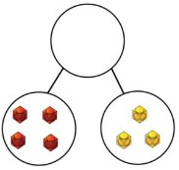  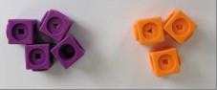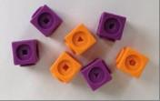  Use part-part-whole model.  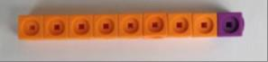  Use cubes to add two numbers together as a group or in a bar. | 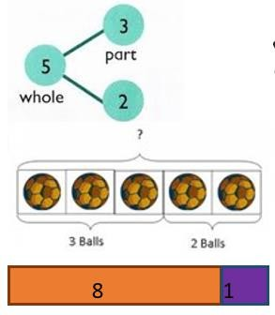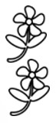  Use pictures to add two numbers together as a group or in a bar. | 4  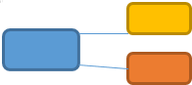  7  3  4 + 3 = 7  Four is a part, 3 is a part and the whole is seven.  10 = 6 + 4  Use the part-part-whole diagram as shown above to move into the abstract.
Starting at the bigger number and counting on | 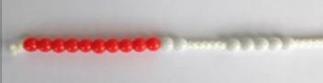  Start with the larger number on the bead string and then count on to the smaller number 1 by 1 to find the answer. | 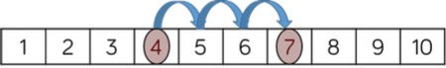  Start at the larger number on the number line and count on in ones or in one jump to find the answer. | 5 + 12 = 17  Place the larger number in your head and count on the smaller number to find your answer.

Regrouping to make 10.  This is an essential skill for column addition later. | 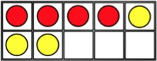  6 + 5 = 11  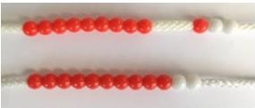  Start with the bigger number and use the smaller number to make 10.  Use ten frames. | 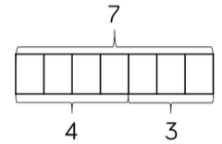  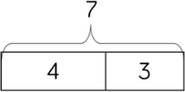  Use pictures of a number line. Regroup or partition the smaller number using the part-part-whole model to make 10. | 7 + 4 = 11  If I am seven, how many more do I need to make 10? How many more do I add on now?  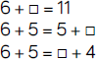  Children to develop an understanding of equality.
Represent and use number bonds and related subtraction facts within 20. | 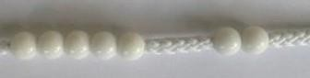  2 more than 5. | 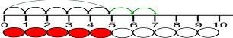  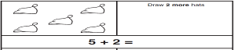 | Emphasis should be on language.  “1 more than 5 is equal to 6.”  “2 more than 5 is 7.”  “8 is 3 more than 5.”

Addition Year 2

Objective &  Strategy | Concrete | Pictorial | Abstract
Adding multiples of ten. | 50 = 30 + 20  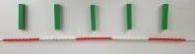  Model using dienes and bead strings. | 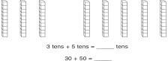  Use representations for base ten. | 20 + 30 = 50  70 = 50 + 20  40 + □ = 60
Use known number facts | 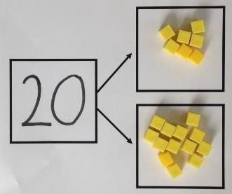  Children explore ways of making numbers within 20. | 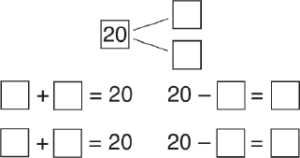 | 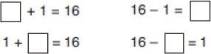
Using known facts | 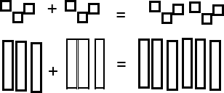 | 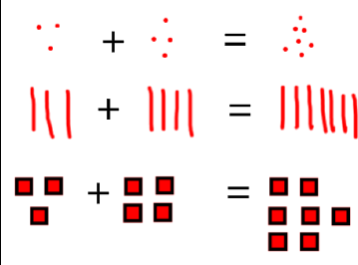  Children draw representations of H, T and O | 3 + 4 = 7  Leads to  30 + 40 = 70  Leads to  300 + 400 = 700

Bar model | 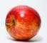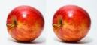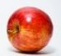  3 + 4 = 7 | 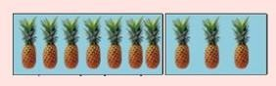  7 + 3 = 10 | 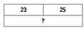  23 + 25 = 48
Add a two- digit number and one. | 7 + 5 = 22  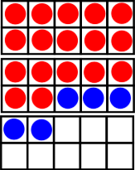  Use ten frame to make “magic ten”  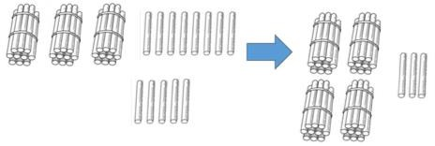 | 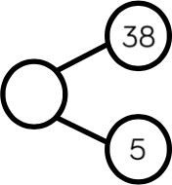  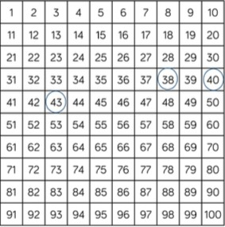  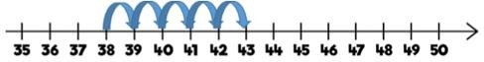 | 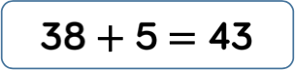  17 + 5 = 22  Explore related facts:  17 + 5 = 22  5 + 17 = 22  22 – 17 = 5  22 – 5 = 17

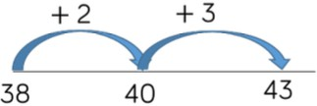

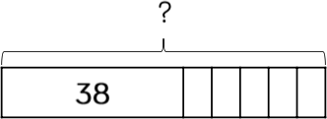
Add a two- digit number and tens | 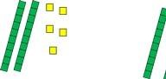  25 + 10 = 35  Explore that the ones digit does not change. | 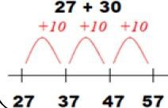 | 27 + 10 = 37  27 + 20 = 47  27 + □ = 57
Add two two- digit numbers | 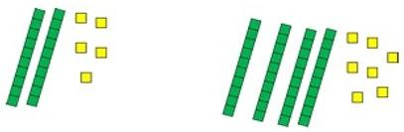  Model using dienes, place value counters and numicon. | Use number line and bridge ten using part-part-whole if necessary  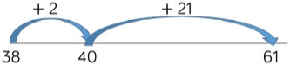 | 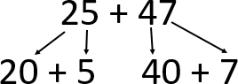  20 + 40 = 60  5 + 7 = 12  60 + 12 = 72

 | 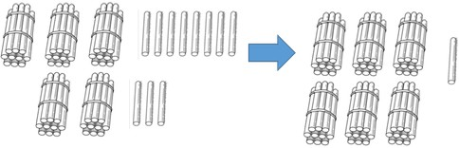  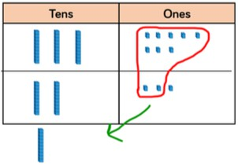  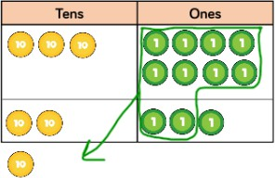 | 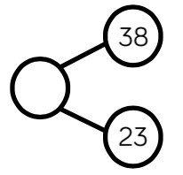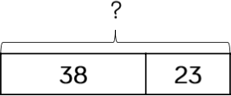 | 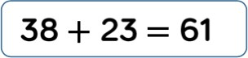
Add three one-digit numbers | 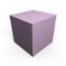  Combine to make 10 first if possible, or bridge 10 then add third digit. | 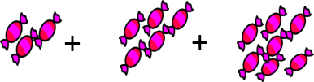  Regroup and draw representation  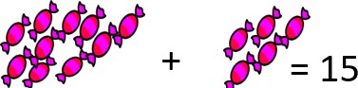 | Combine the two number that make/bridge ten then add on the third.  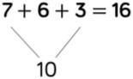

 | 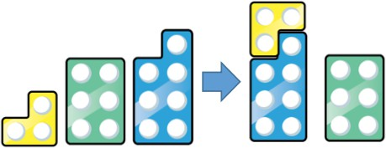  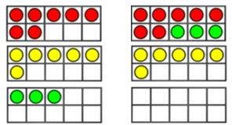 | 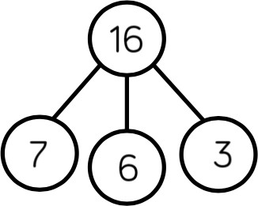  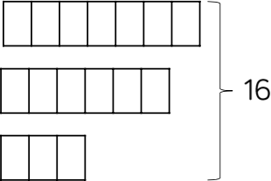 | 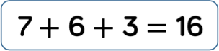
Column Addition – no regrouping (friendly numbers) | 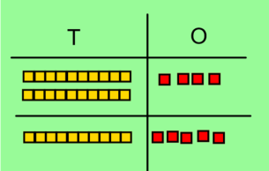  Model using dienes or Numicon.  Add together the ones first, then the tens. | 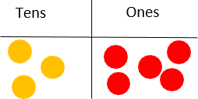 | 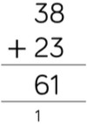  Add the ones first, then the tens, then the hundreds.

 | 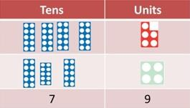  Move to using place value counters. | Children move to drawing the counters using a tens and one frame.
Column Addition – with regrouping | 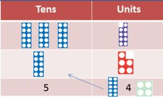  Exchange ten ones for a ten. Model using numicon and place value counters. | 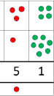  Children to draw a representation of the grid to further support their understanding, carrying the ten underneath the line. | 20 + 5 36  40 + 8 + 85  60 + 13 = 73 121  1  Start by partitioning the numbers before formal column to show the exchanging.

Addition Year 3-6

Objective & Strategy | Concrete | Pictorial | Abstract
Year 3  Add numbers with up to 3 digits | 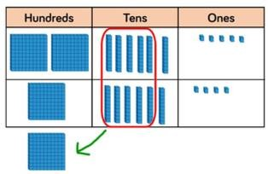  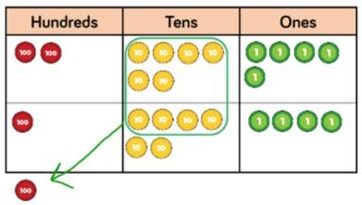 | 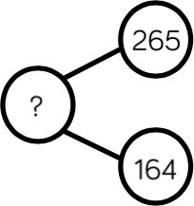  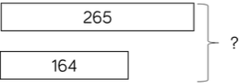  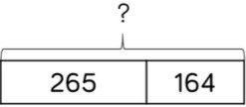 | 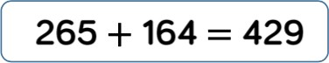  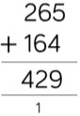

Year 4 Add numbers  with up to 4 digits | 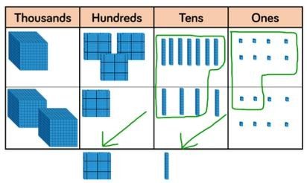  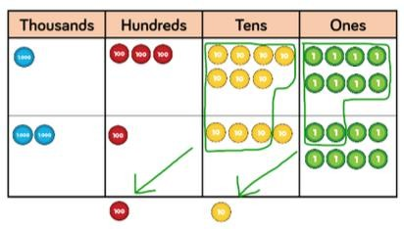 | 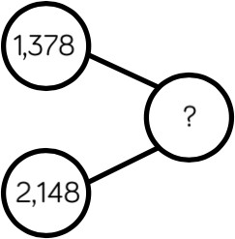  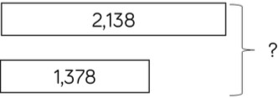  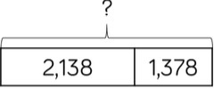 | 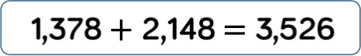  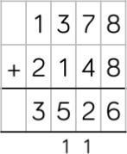

Year 5 and 6 Add numbers with more than 4 digits | 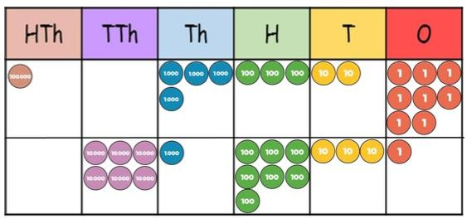 | 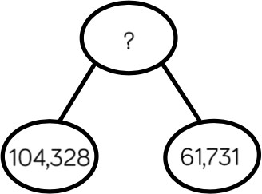  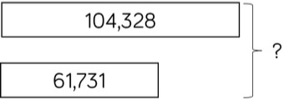  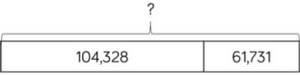 | 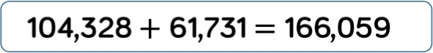  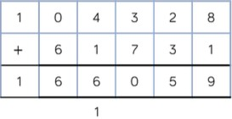
Year 5 and 6 Add numbers with up to 3 decimal places | 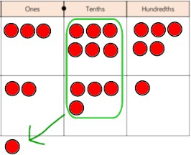 | 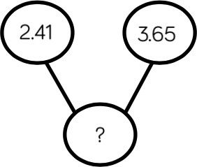 | 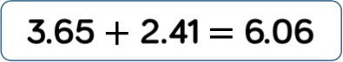  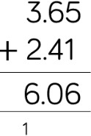

 | 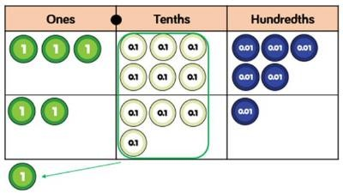 | 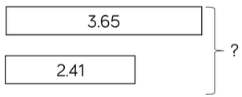  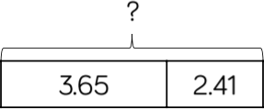

Subtraction Year 1

Objective & Strategy | Concrete | Pictorial | Abstract
Taking away ones. | 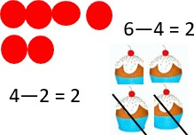  Use physical objects, counters, cubes etc to show how objects can be taken away. | 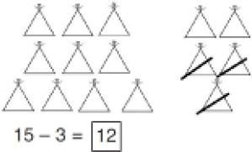  Cross out drawn objects to show what has been taken away. | 7 – 4 = 3  16 – 9 = 7
Counting back. |   Move objects away from the group, counting backwards.  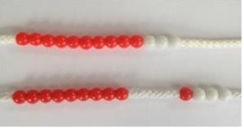  Move the beads along the bead string as you count backwards. | 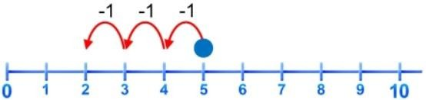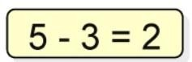  Count back in ones using a number line. | Put 13 in your head, count back 4. What number are you at?

Find the difference. | 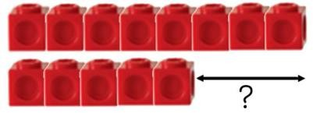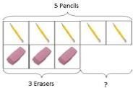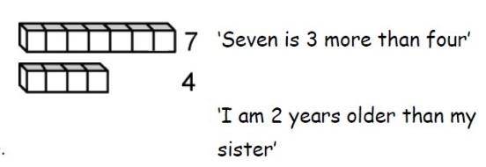  Compare objects and amounts.  Lay objects to represent bar model. | 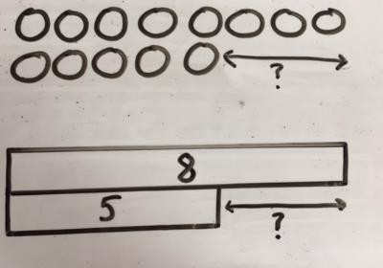  Children to draw the cubes/other concrete objects which they have used or use the bar model to illustrate what they need to calculate.  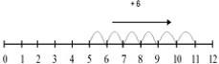  Count on using a number line to find the difference. | Hannah has 12 sweets and her sister has 5. How many more does Hannah have than her sister?  Find the difference between 8 and 5. 8 – 5, the difference is □  Children to explore why  9 – 6 = 8 – 5 = 7 – 4 have the same difference.
Represent and use number bonds and related subtraction facts within 20.  Part-part-whole model. | 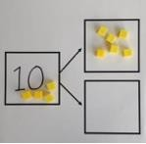  Link to addition. Use part-part-whole model to model the inverse.  If 10 is the whole and 6 is one of the parts, what is the other part? |   Use pictorial representations to show the part. | 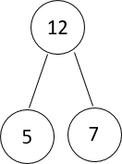  Move to using numbers within the part- part-whole model.
Make 10. | 14 - 5

 | 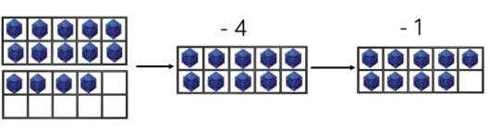  Make 14 of the ten frame. Take 4 away to make ten, then take one more away so that you have taken 5. | 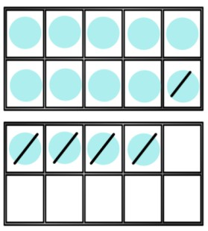  Children to present the ten frame pictorially and discuss what they did to make 10.  13 – 7  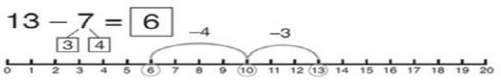  Jump back 3 first, then another 4. Use ten as the stopping point. | 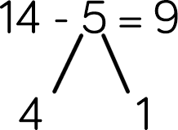  14 – 4 = 10  10 – 1 = 9  Children to show how they can make 10 by partitioning the subtrahend.  16 – 8  How many do we take off first to get to 10? How many left to take off?
Bar Model. |  | 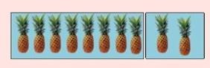
 | 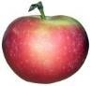  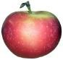  5 – 2 = 3 |  | 8 2  10 = 8 + 2
 |  |  | 10 = 2 + 8
 |  |  | 10 – 2 = 8
 |  |  | 10 – 8 = 2

Subtraction Year 2

Objective & Strategy | Concrete | Pictorial | Abstract
Regroup a ten into ten ones | 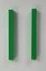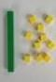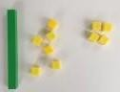  Use a place value chart to show how to change a ten into ten ones. Use the term “take and make”. | 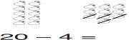 | 20 – 4 = 16
Partition to subtract without regrouping (friendly numbers). | 34 – 13 = 21  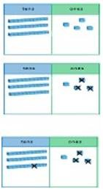  Use dienes to show how to partition the number when subtracting without  regrouping. | 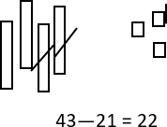  Children draw representations of dienes and cross off. | 43 – 21 = 22

Make ten strategies. Progression should be crossing one ten, crossing more than one ten, crossing the hundreds. | 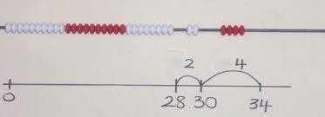  Use a bead bar or bead strings to model counting to next ten and the rest. | 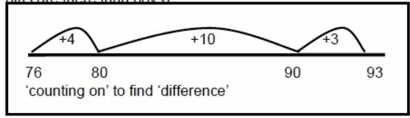  Use a number line to count on to next ten and then the rest. | 93 – 76 = 17
Column subtraction without regrouping (friendly numbers) | 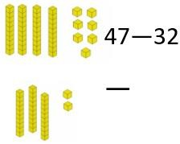  Use base 10 or numicon to model. | 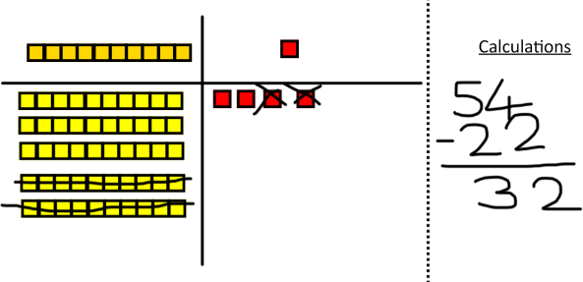  Draw representations to support understanding.  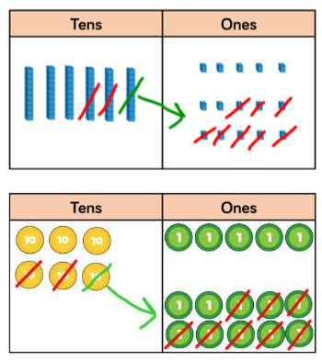 | 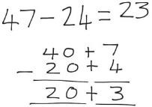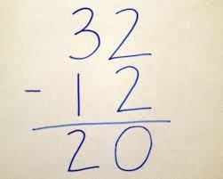  Intermediate step may be needed to lead to clear subtraction understanding.

Subtraction Year 3-6

Objective & Strategy | Concrete | Pictorial | Abstract
Year 3  Subtract numbers with up to 3 digits | 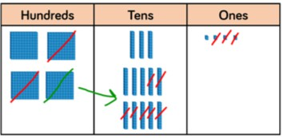  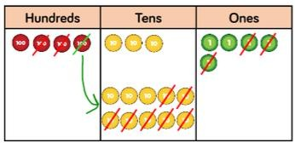 | 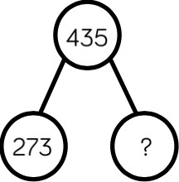  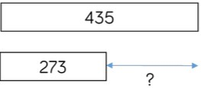  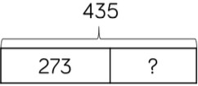 | 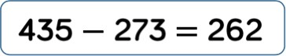  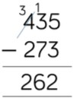
Year 4  Subtract numbers with up to 4 digits |  |  | 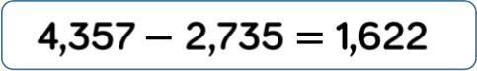

 | 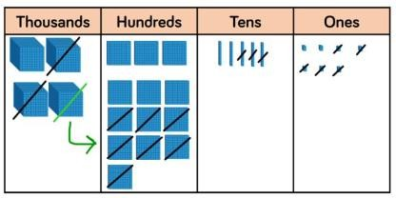  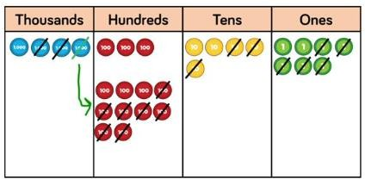 | 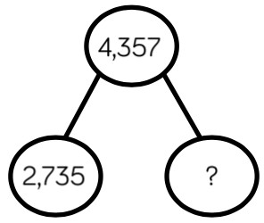  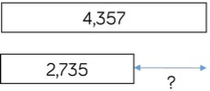  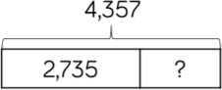 | 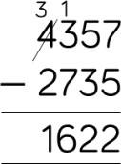
Year 5 and 6 Subtract numbers with more than 4 digits | 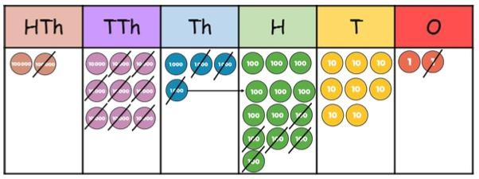 | 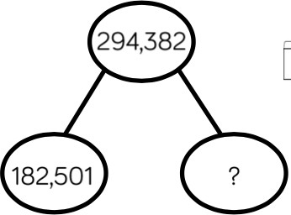 | 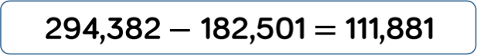  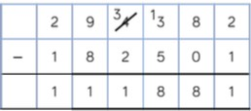

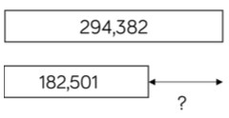

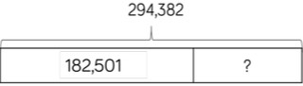
Year 5 and 6 Subtract numbers with up to 3 decimal places | 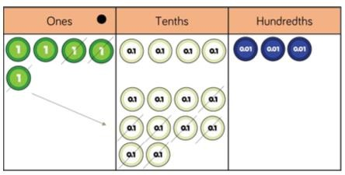  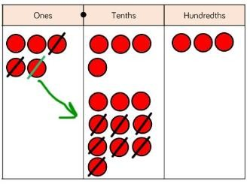 | 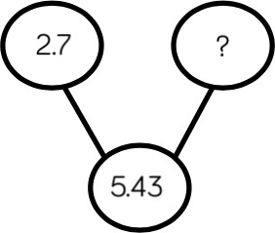  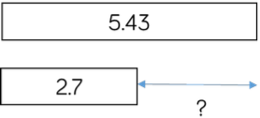  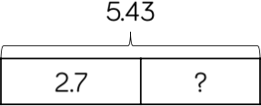 | 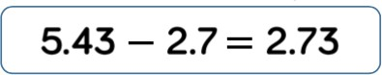  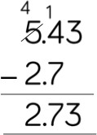

Multiplication Year 1

Objective & Strategy | Concrete | Pictorial | Abstract
Doubling. | 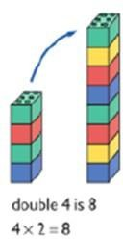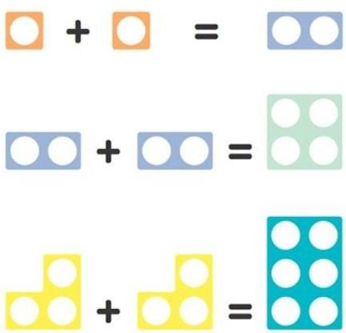  Use practical activities using manipulatives including cubes and numicon to demonstrate doubling. | 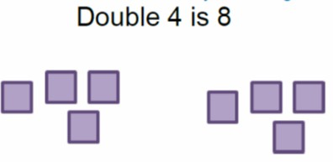  Draw pictures to show how to double numbers. | 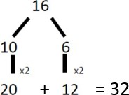  Partition a number and then double each part before recombining it back together.
Counting in multiples. | 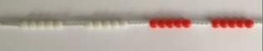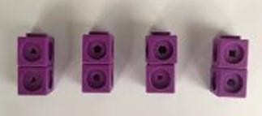  Count the groups as children are skip counting, children may use fingers as they are skip counting. | 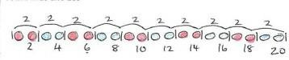  Children make representations to show counting in multiples. | Count in multiples of a number aloud.  Write sequences with multiples of number.  2, 4, 6, 8, 10  5, 10, 15, 20, 25, 30
Making equal groups and counting the total |  | Draw and make representations. | 2 x 4 = 8

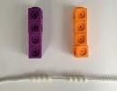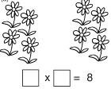
Use manipulatives to create equal groups.
Repeated addition | 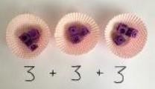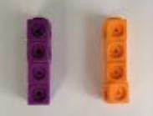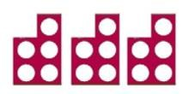  Use different objects to add equal group. | 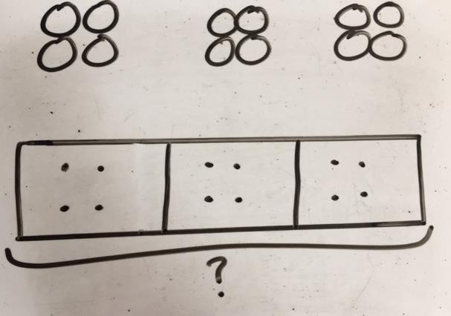  Children to represent the practical resources in a picture and use a bar model. | 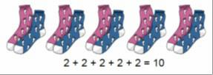  Write addition sentences to describe objects and pictures.
Understanding arrays | 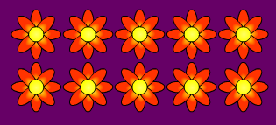  Use objects laid out in arrays to find the answers to 2 lots of 5, 3 lots of 2 etc. | 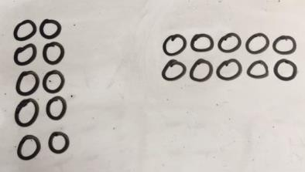  Draw representation of arrays to show understanding. | 10 = 2 x 5  5 x 2 = 10  2 + 2 + 2 + 2 + 2 = 10  10 = 5 + 5  Children to be able to use an array to write a range of calculations.

Multiplication Year 2

Objective &  Strategy | Concrete | Pictorial | Abstract
Doubling | 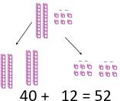  Model doubling using dienes and place value counters. | Draw pictures and representations to show how to double numbers. | Partition a number and then double each part before recombining it back together.
Counting in multiples of 2, 3, 4,  5, 10 from 0 (repeated addition) | 5 + 5 + 5 + 5 + 5 + 5 + 5 + 5 = 40  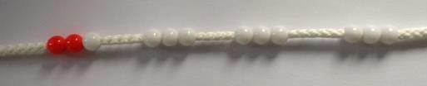  Count the groups as children are skip counting. Children may use their fingers as they are skip counting. Use bar models.  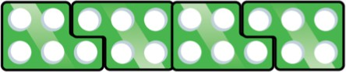 | 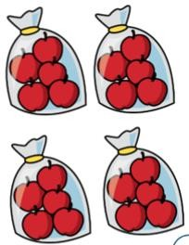  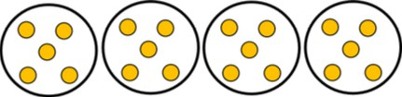 | 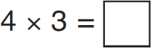  Count in multiples of a number aloud.  Write sequences with multiples of numbers.  0, 2, 4, 6, 8, 10  0, 3, 6, 9, 12, 15  0, 5, 10, 15, 20, 25, 30

 | 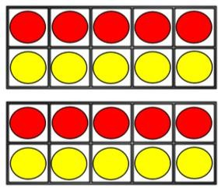 | 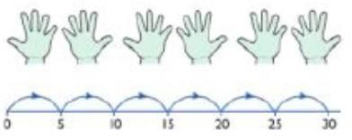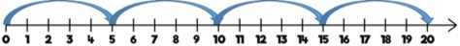  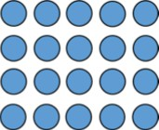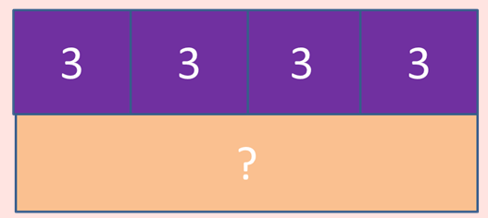  Number lines, counting sticks and bar models should be used to show representation of counting in multiples. | 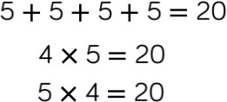  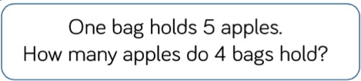

Multiplication is commutative | 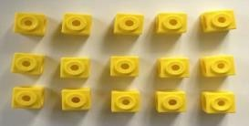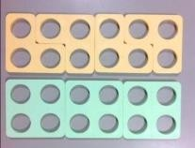  Create arrays using counters and cubes and numicon.  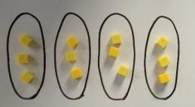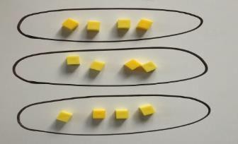  Pupils should understand that an array can represent different equations and that, as multiplication is commutative, the order of the multiplication does not affect the answer. | 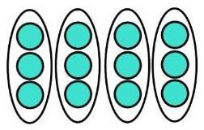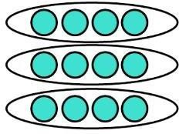  Use representative of arrays to show different calculations and explore commutativity. | 12 = 3 x 4  12 = 4 x 3  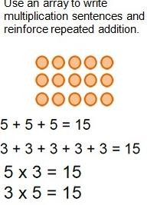
Using the inverse This should be taught alongside division, so pupils learn how they work alongside each other. | 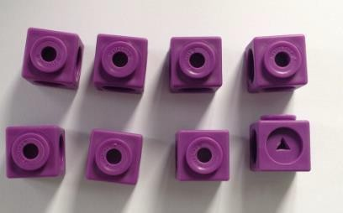 | 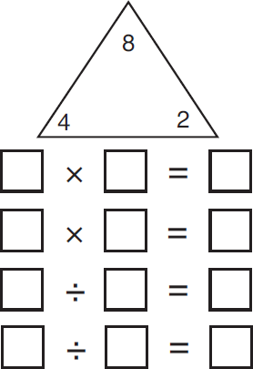 | 2 x 4 = 8  4 x 2 = 8  8 ÷ 2 = 4  8 ÷ 4 = 2  8 = 2 x 4  8 = 4 x 2  2 = 8 ÷ 4  4 = 8 ÷ 2  Show all 8 relevant fact family  sentences.

Objective &  Strategy | Concrete | Pictorial | Abstract
Grid method. | 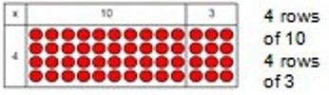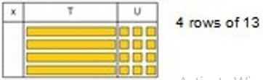  Show the links with arrays to first introduce the grid method.  Move onto dienes to move towards a more compact method.  Move on to place value counters to show how we are finding groups of a number. We are multiplying by 4 so we need 4 rows.  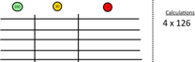  Fill each row with 126.  Add up each column, starting with the ones making any exchanges needed.  Then you have your answer. | Children can represent their work with place value counters in a way that they understand.  They can draw the counters using colours to show different amounts or just use the circles in the different columns to show their thinking as shown below.  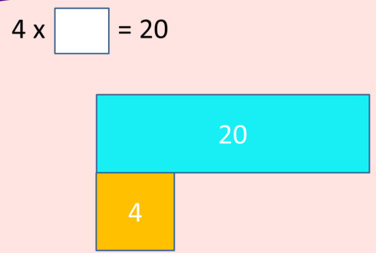  Bar models are used to explore missing numbers. | 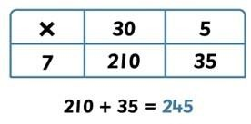  Start with multiplying by one digit numbers and showing the clear addition alongside the grid.  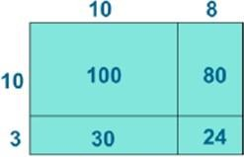  100  80  30  + 4  214  1  Moving forward, multiply by a two- digit number showing the different rows within the grid method.

Objective &  Strategy | Concrete | Pictorial | Abstract
Grid method recap from Year 3 for two- digit x one-digit | Move on to place value counters to show how we are finding groups of a number. We are multiplying by 4 so we need 4 rows.  Fill each row with 126.  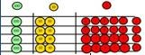  Add up each column, starting with the ones making any exchanges needed.  Then you have your answer. | Children can represent their work with place value counters in a way that they understand.  They can draw the counters using colours to show different amounts or just use the circles in the different columns to show their thinking as shown below. | Start with multiplying by one-digit numbers and showing the clear addition alongside the grid.
Column multiplication (two-digit by one- digit) | Children can continue to be supported by place value counters at the stage of multiplication.  This initially done where there is no regrouping. 321 x 6 = 642 Does this mean 321 x 2?  It is important at this stage that they always multiply the ones first.  The corresponding long multiplication is modelled alongside. | 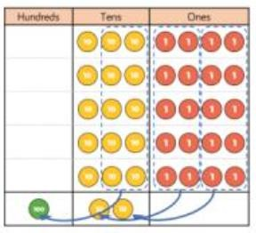 | 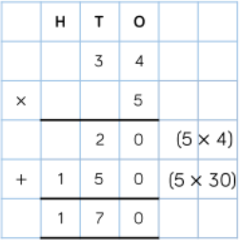

 | 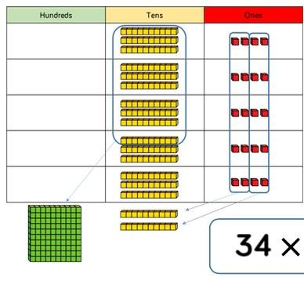 |  | 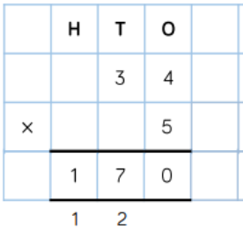
Column multiplication (three-digit by one- digit) | 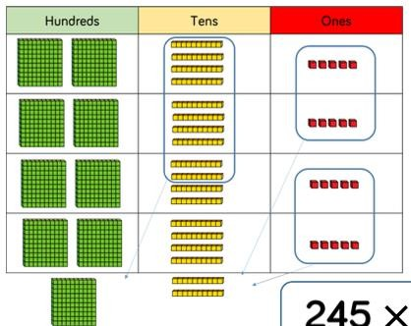 | 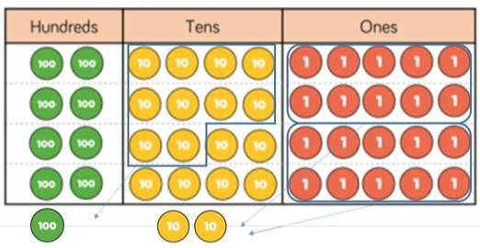 | 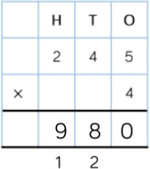

Multiplication Year 5-6

Objective &  Strategy | Concrete | Pictorial | Abstract
Column multiplication for three and four-digit x one-digit |  | 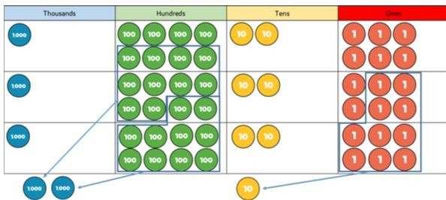 | 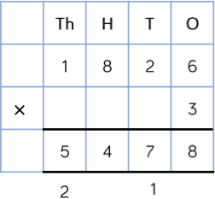
Column multiplication for two-digit x two-digit | 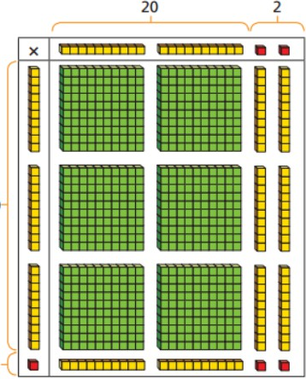 | 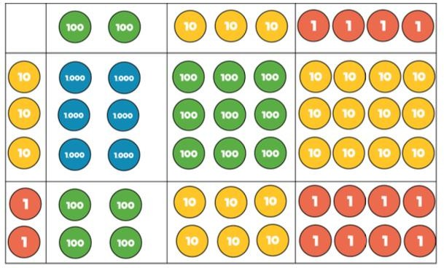 | 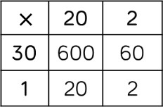  600  60  20  + 2  682

 |  |  | 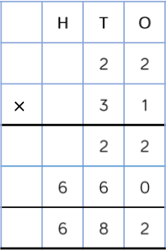
 |  | 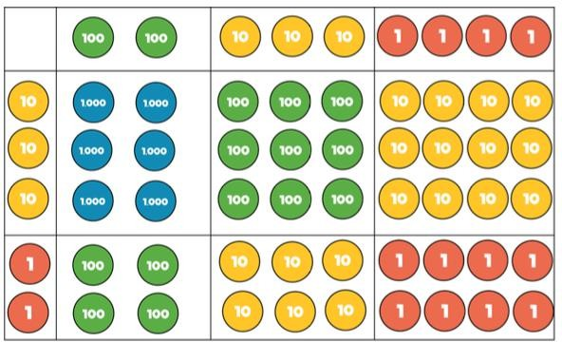 | 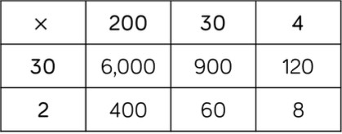  6000  900  120  400  60  + 8  7488

 |  |  | 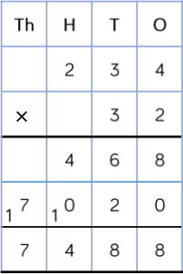
Multiply four- digit numbers by two-digit numbers |  |  | 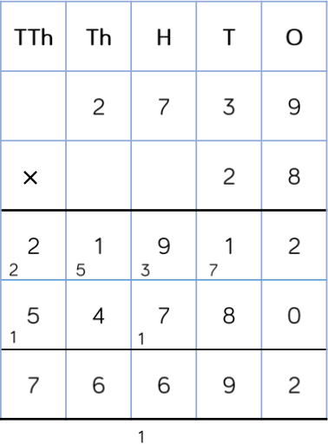

Objective &  Strategy | Concrete | Pictorial | Abstract
Multiplying numbers with up to two decimal places by a single digit. |  |  | 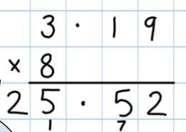  Remind children that the single digit belongs to the ones column. Line up the decimal point in the question and the answer.

Objective &  Strategy | Concrete | Pictorial | Abstract
Division as sharing | 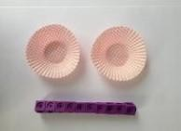  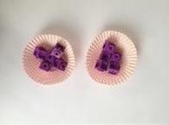  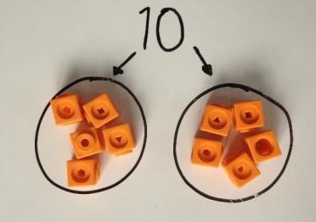  I have 10 cubes; can you share them equally in 2 groups? | 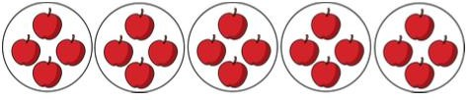  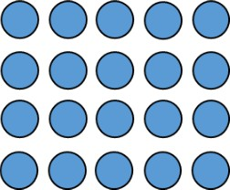  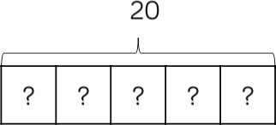 | 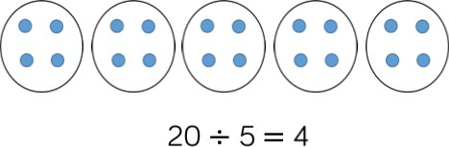  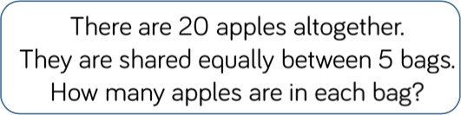
Division as grouping |  | 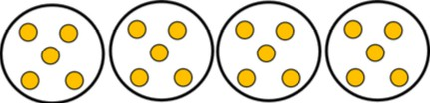 | 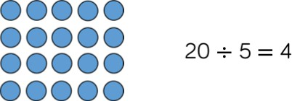

 | 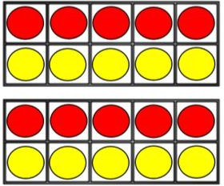 | 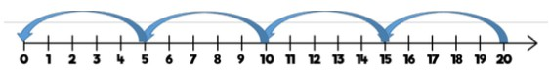 | 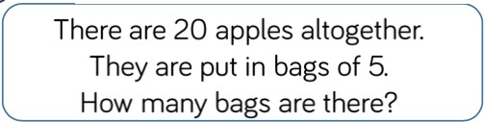

Objective &  Strategy | Concrete | Pictorial | Abstract
Divide two-digit by one-digit (sharing with no exchange) | 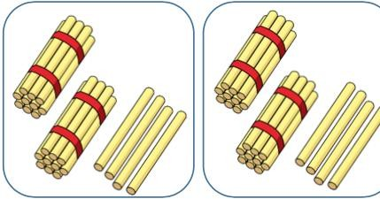  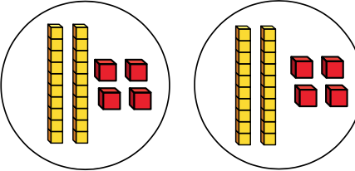 | 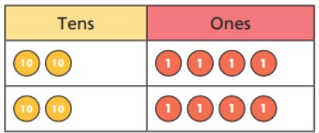  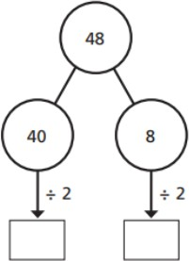 | 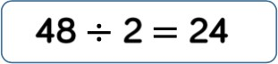

Objective &  Strategy | Concrete | Pictorial | Abstract
Divide two-digit by one-digit (share with exchange) | 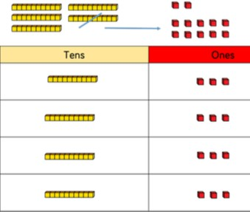 | 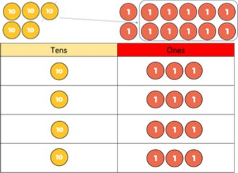  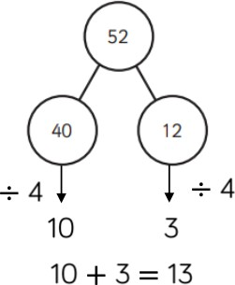 | 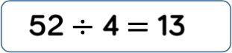

 |  | 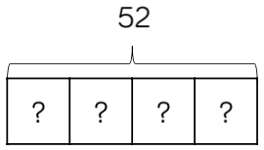
Divide two-digit by one-digit (sharing with remainders) | 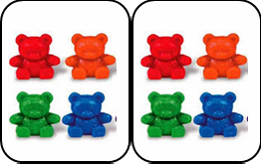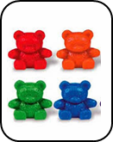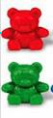  Divide objects between groups and see how much is left over.  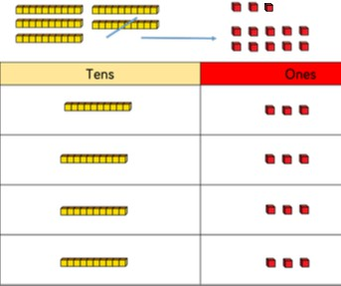 | 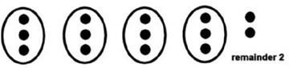  Draw dots and group them to divide an amount and clearly show a remainder  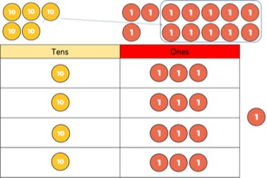  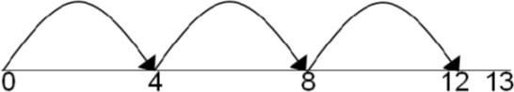  Jump forward in equal jumps on a number line then see how many more you need to jump to find a remainder. | 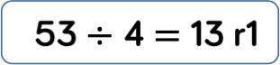

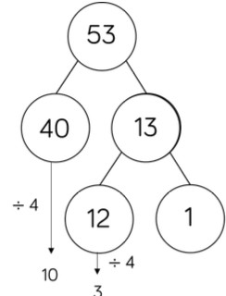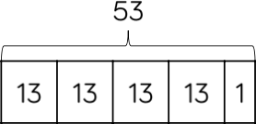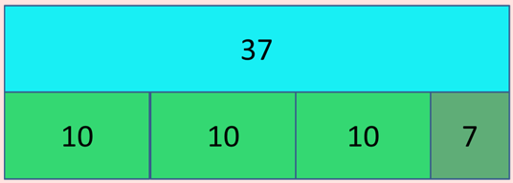

Use bar models to show division with remainders.

Division Year 4 - 6

Objective &  Strategy | Concrete | Pictorial | Abstract
Year 4  Divide two-digit by one-digit (grouping) | 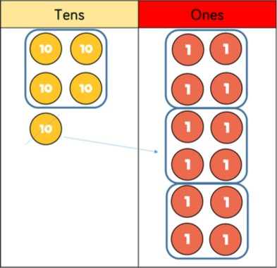 | 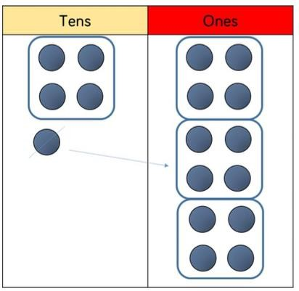 | 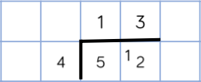
Year 4 and 5 Divide three- digit by one- digit (sharing) | 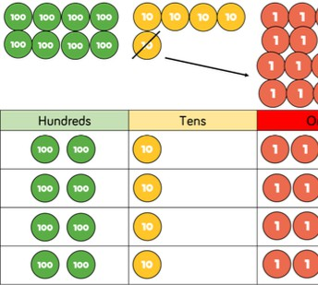 | 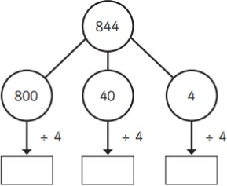  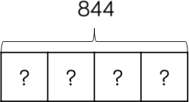 | 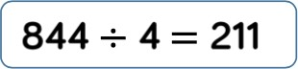

Year 5 and 6 Divide three- digit by one- digit (grouping)  Divide four- digits by one- digit | 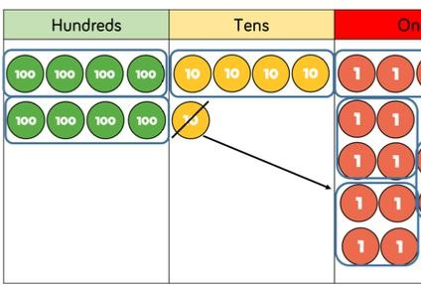 | 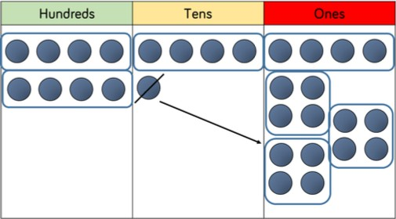  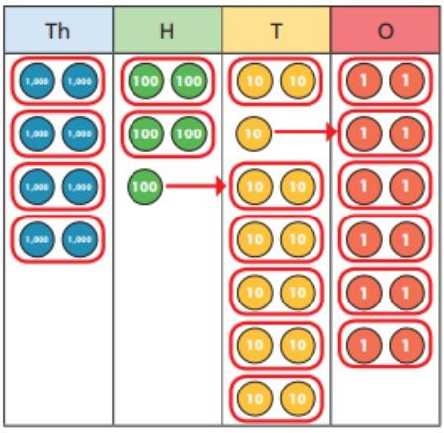 | 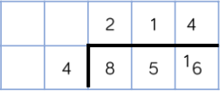  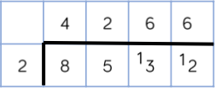
Year 6 Division with reminders |  |  | Begin with divisions that divide equally with no remainder.  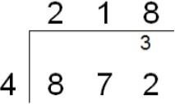  Move on to divisions with a remainder.

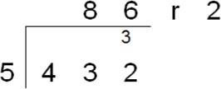
Finally move into decimal places to divide the total accurately.
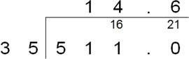

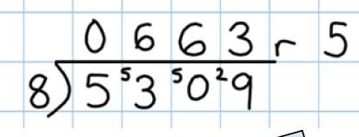

Division Year 6

Objective &  Strategy | Concrete | Pictorial | Abstract
Divide multi digits by two- digits (short division) |  | 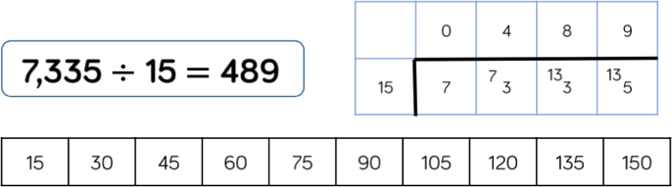 | 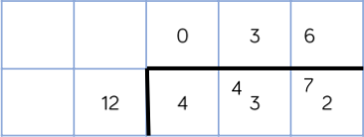
Divide multi- digits by two- digits (long division) |  |  | 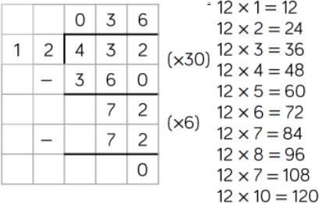

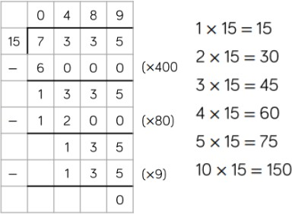

Alternative “chunking” method to be used to only support with pupils needing identified as needing additional support/ alternative strategy.

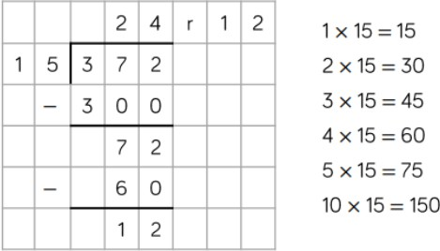

Signed CEO:

Signed Chair of Directors:
Policy to be reviewed: Spring 2023

